How to send your information
1: Please copy this table and paste it in a new email to E.Kispeter@warwick.ac.uk with the subject: Historic England diversity research.
Name of organisation:
Name of person completing this table:
Email address:
We don’t collect any data
We do collect data on the demographic characteristics of our paid staff
(Yes No or N/A)
We do collect data on the demographic characteristics of our volunteers
(Yes No or N/A)
We do collect data on the demographic characteristics of our trustees/board (Yes No or N/A)
I have uploaded a report on this data on the portal (Yes or No)
I have data but cannot upload it.
I have emailed it or posted it (please say which)

2. If you have a data or a report that is an electronic file and can share it with us please follow these instructions to upload it:
Please send your reports (and any data sets which support them) on the characteristics of your workers, volunteers and those involved in governance roles which have been produced in electronic form via the secure file transfer facility provided by the University of Warwick.
Go to the web address: https://files.warwick.ac.uk/ .
Select ‘Upload a file for someone at Warwick’
Fill in the pop-up form, with “Kispeter” in the name of the person to send the file to (this will give you the name “Erika Kispeter” as a pop-up, click on this name). Then fill in your details (including any message describing your reports) and browse to the file to be sent. Then click on “upload and send file”. You will receive an e-mail acknowledging receipt.
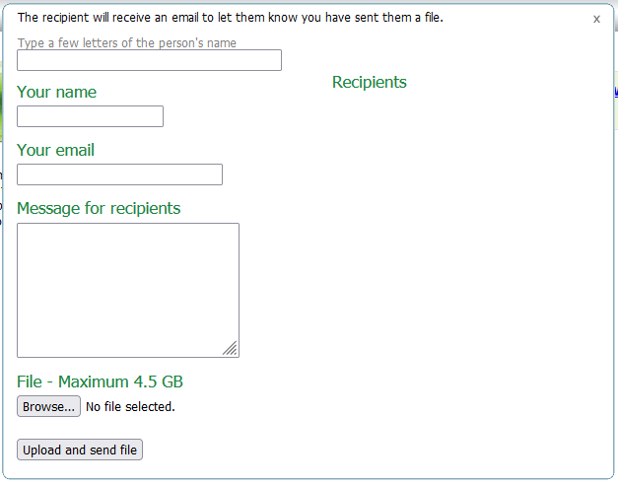
It will look like this. (this is not the form – it’s just to show what it will look like when you follow the link)

3. If you have data or reports on the characteristics of your staff, volunteers or trustees but would prefer to communicate by post or to email the data directly please send it to:
Erika Kispeter,
Institute for Employment Research,
Social Sciences Building,
University of Warwick,
Coventry CV4 7AL.
Tel: 024 7652 4477

E-mail: E.Kispeter@warwick.ac.uk

